**Abstract title in Times New Roman 16 bold**

A.B. Author, C. Coauthor,…

*Affiliation in Times New Roman 12 Italic*

Abstract text, Author names and References in Times New Roman 12. Lorem ipsum dolor sit amet, consectetur adipiscing elit. Lorem ipsum dolor sit amet, consectetur adipiscing elit. Lorem ipsum dolor sit amet, consectetur adipiscing elit [1]. Lorem ipsum dolor sit amet, consectetur adipiscing elit. Lorem ipsum dolor sit amet, consectetur adipiscing elit. Lorem ipsum dolor sit amet, consectetur adipiscing elit. Lorem ipsum dolor sit amet, consectetur adipiscing elit. Lorem ipsum dolor sit amet, consectetur adipiscing elit [2]. Lorem ipsum dolor sit amet, consectetur adipiscing elit. Lorem ipsum dolor sit amet, consectetur adipiscing elit. Lorem ipsum dolor sit amet, consectetur adipiscing elit (fig.1). Lorem ipsum dolor sit amet, consectetur adipiscing elit. Lorem ipsum dolor sit amet, consectetur adipiscing elit. Lorem [3] ipsum dolor sit amet, consectetur adipiscing elit. Lorem ipsum dolor sit amet, consectetur adipiscing elit. Lorem ipsum dolor sit amet, consectetur adipiscing elit. Lorem ipsum dolor sit amet, consectetur adipiscing elit [4]. Lorem ipsum dolor sit amet, consectetur adipiscing elit. Lorem ipsum dolor sit amet, consectetur adipiscing elit. Lorem ipsum dolor sit amet, consectetur adipiscing elit. Lorem ipsum dolor sit amet, consectetur adipiscing elit. Lorem ipsum dolor sit amet, consectetur adipiscing elit. Lorem ipsum dolor sit amet, consectetur adipiscing elit [5]. Lorem ipsum dolor sit amet, consectetur adipiscing elit. Lorem ipsum dolor sit amet, consectetur adipiscing elit. Lorem ipsum dolor sit amet, consectetur adipiscing elit. Lorem ipsum dolor sit amet, consectetur adipiscing elit. Lorem ipsum dolor sit amet, consectetur adipiscing elit. Lorem ipsum [6] dolor sit amet, consectetur adipiscing elit.

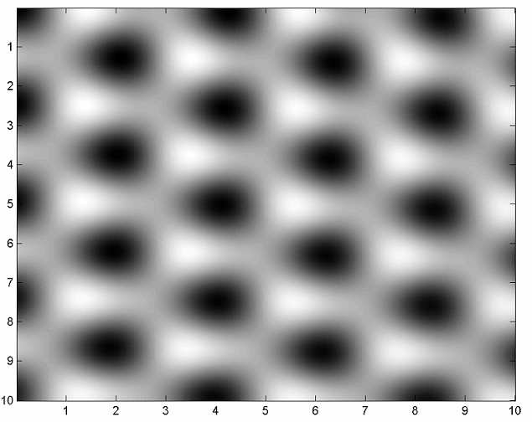

Fig. 1: Figure caption in times new roman 11

References

[1] C.R. Clemmer, T.P. Beebe Jr., *Science* **251** (1991) 640

[2] J. Xhie, K. Sattler, M. Ge, N. Venkateswaran, *Phys. Rev. B* **47** (1993) 15835

[3] R. Hentschke, B. Schurmann, J. Rabe, *J. Chem. Phys.* **96** (1992) 6213

[4] W.T. Pong, C. Durkan, J. Bendall, “*Observation of Large-Scale Features on Graphite under Scanning Tunnelling Microscope*” 12th International Colloquium on Scanning Probe Microscopy in Shizuoka, Japan 2004.

[5] J. Osing, I.V.Shvets, *Surf. Sci.* **417** (1998) 145

[6] V. J. Cee, D. L. Patrick, T. P. Beebe Jr., *Surf. Sci.* **329** (1995) 141